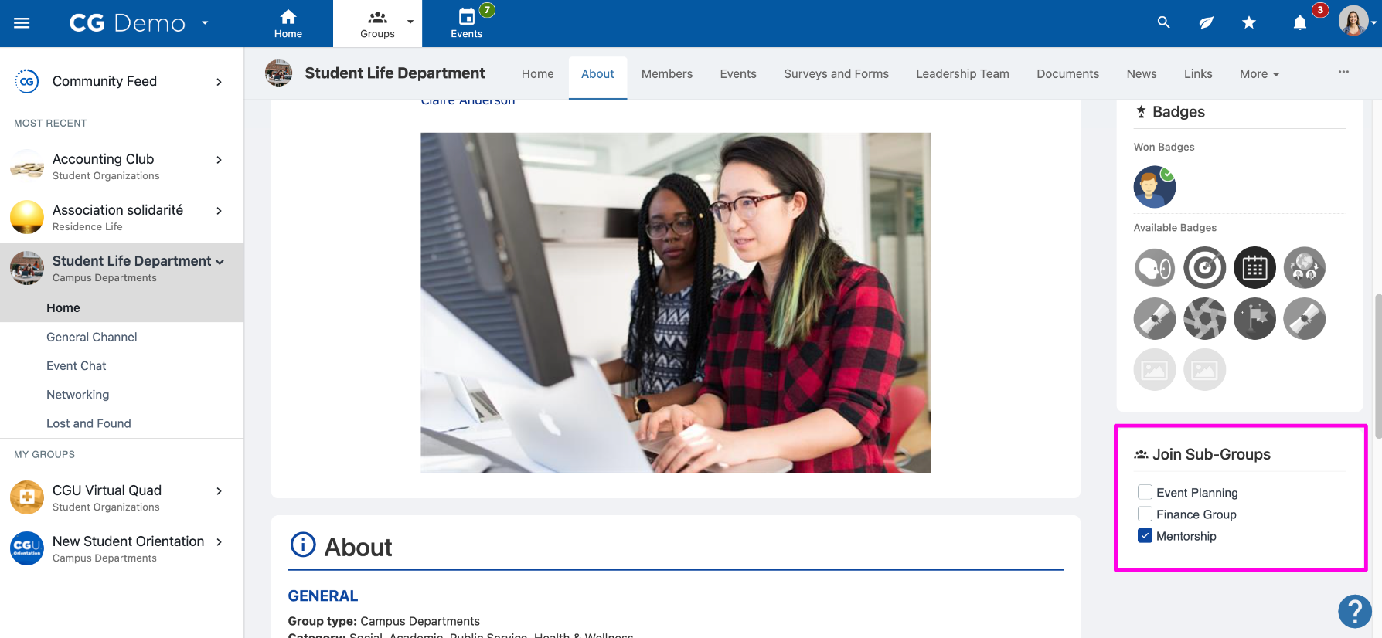
Members can join Sub-Groups by navigating to the Group Page

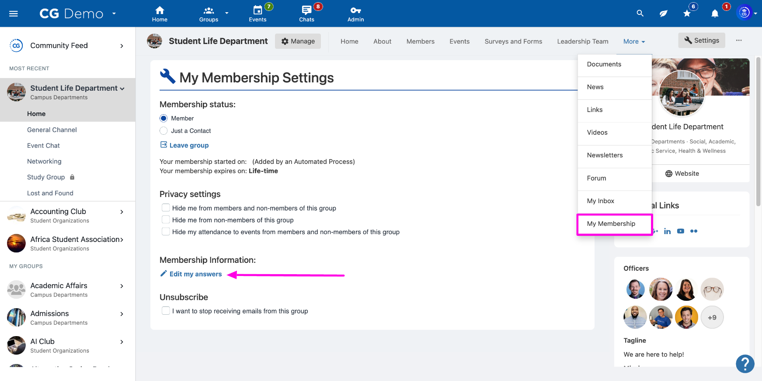
Members can change their answers to required Custom Fields or add answers to non-required Custom Fields by navigating to the Group Page, selecting My Membership and clicking Edit my answers

